**ניהול פרויקט תוכנה – עבודת הגשה 6**

**מגישים:**  
ליאור וקנין  
פבל שוורצוב  
מורדי דבח

Forking the chosen project on GitHub:

A link to the forked repository: <https://github.com/Shvarpa/gif-for-cli>

Analyze the initial technical debt of the project:

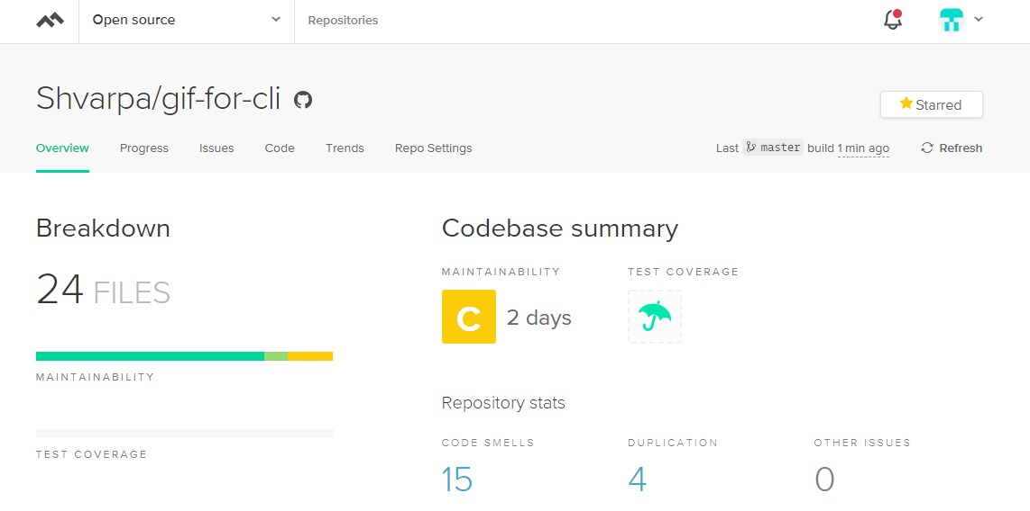

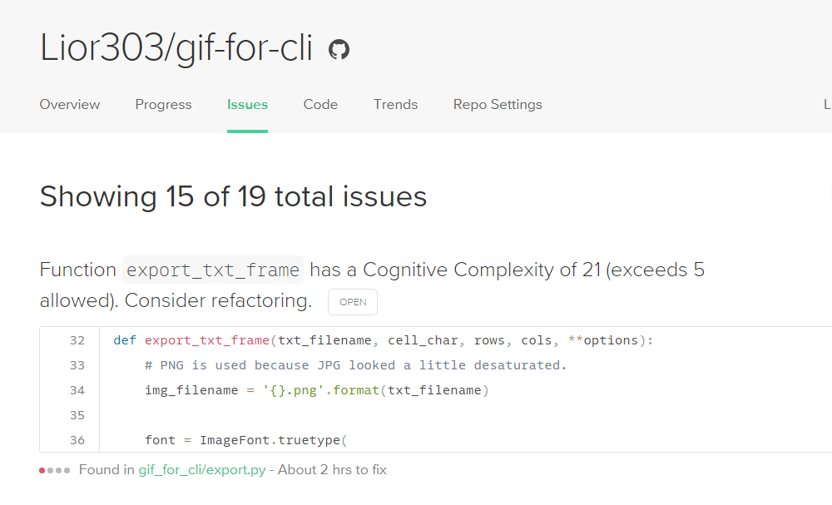We can see that the initial technical debt of the project is two days, with 15 code smells.

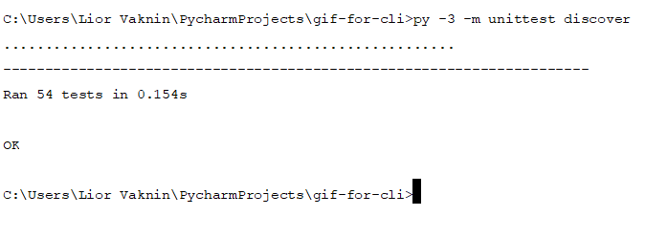

We can see that at the beginning all the tests (54) passed.

**Refactoring:**

Code smell number one:

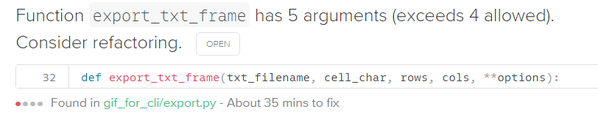

In this function there are five arguments but 4 allowed.



We can see that the fifth argument (**options) is not used in this function. Therefore, we can delete it. All the tests passed.

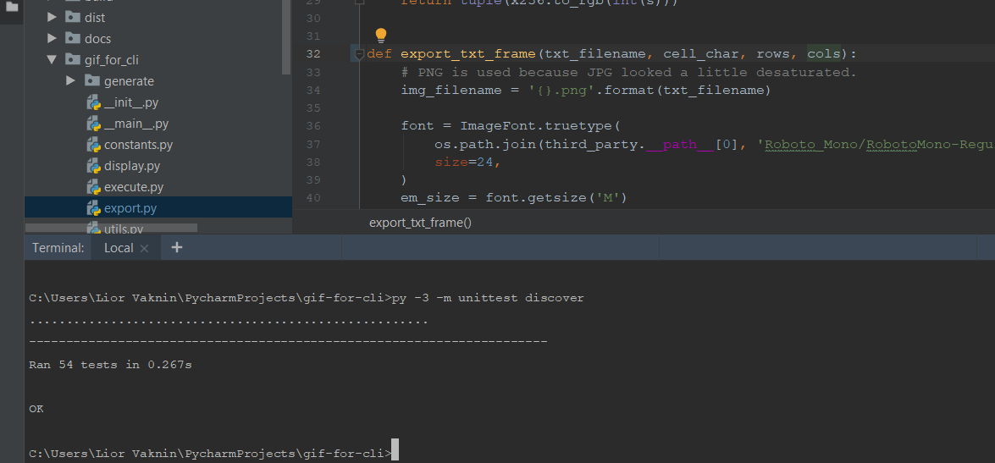

Code smell number 2:

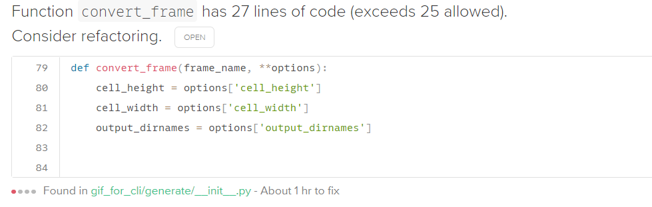

We can divide functionality of the function convert_frame into several functions.

Before:

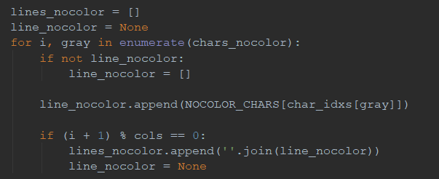

The setup of the list line_nocolor was in the function convert_frame. Divide this setup to function setup_line_nocolor.

After:

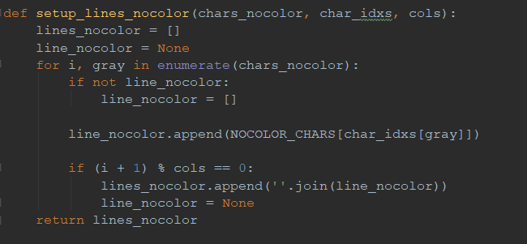



And all the tests passed.

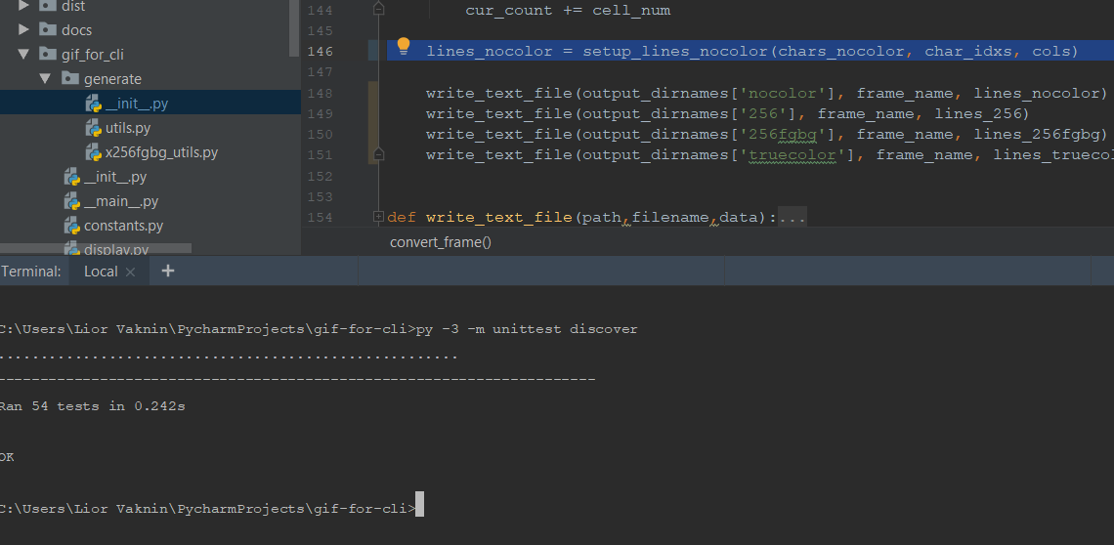

Code smell number 3: